Chemical Competition in Plants
Developed by J. Swanson, J. Budke & B. Goffinet and amended
by K. Lombard for ECE workshop March 2015

Objective: This lab exercise uses the moss Sphagnum to examine chemical competition in plant ecology.

Introduction: A resource can be defined as any part of the environment that an organism uses for its growth, maintenance, and reproduction. In nature, food and water are common examples of resources. However, some resources may be in limited supply. A frequently overlooked resource is space. Although not “used up”, space can be in short supply in many environments and competition for space can be fierce. Plants compete for space above ground primarily to acquire light for photosynthesis. Some plants outcompete their neighbors by growing taller and faster. Other plants take a subtle, yet extremely effective approach: chemical alteration of the environment to prevent the growth of competitors. This strategy is displayed by a group of bryophytes, the peatmosses (Sphagnum). In this lab, you will monitor the water chemistry, specifically pH, of a sample of Sphagnum in water.

Part A. Experimental Question:
How does Sphagnum alter its watery environment to compete against
neighboring plants?

Compose a hypothesis:

Materials:

- 2 x 250 mL beakers (or similar sized containers)
- Conditioned tap water (or Pond or Spring water)
- Graduated cylinder, 100 mL
- Sphagnum moss, rinsed (Carolina Biological Supply Co. #156740)
- Aquatic plant (Elodea, Egeria, or Duckweed)
- Digital balance
- Vernier LabQuest unit with two pH electrodes
- Timer
- Squirt bottle of distilled water to rinse electrode
- Waste beaker for catching rinse water

Procedure:
- Turn on the LabQuest unit if it is not already on. The pH electrodes should be in a “holding solution”.

- Obtain two clean beakers, labeled “A” and “B”.
- Measure and add 150 mL of conditioned water to each beaker A & B.
- Rinse one pH electrode and place in beaker A, rinse the other electrode and place in beaker B. Note which channel (1 or 2) each electrode is connected to.

- When the pH stabilizes, record the initial values (Time 0) for each beaker in Table 1.

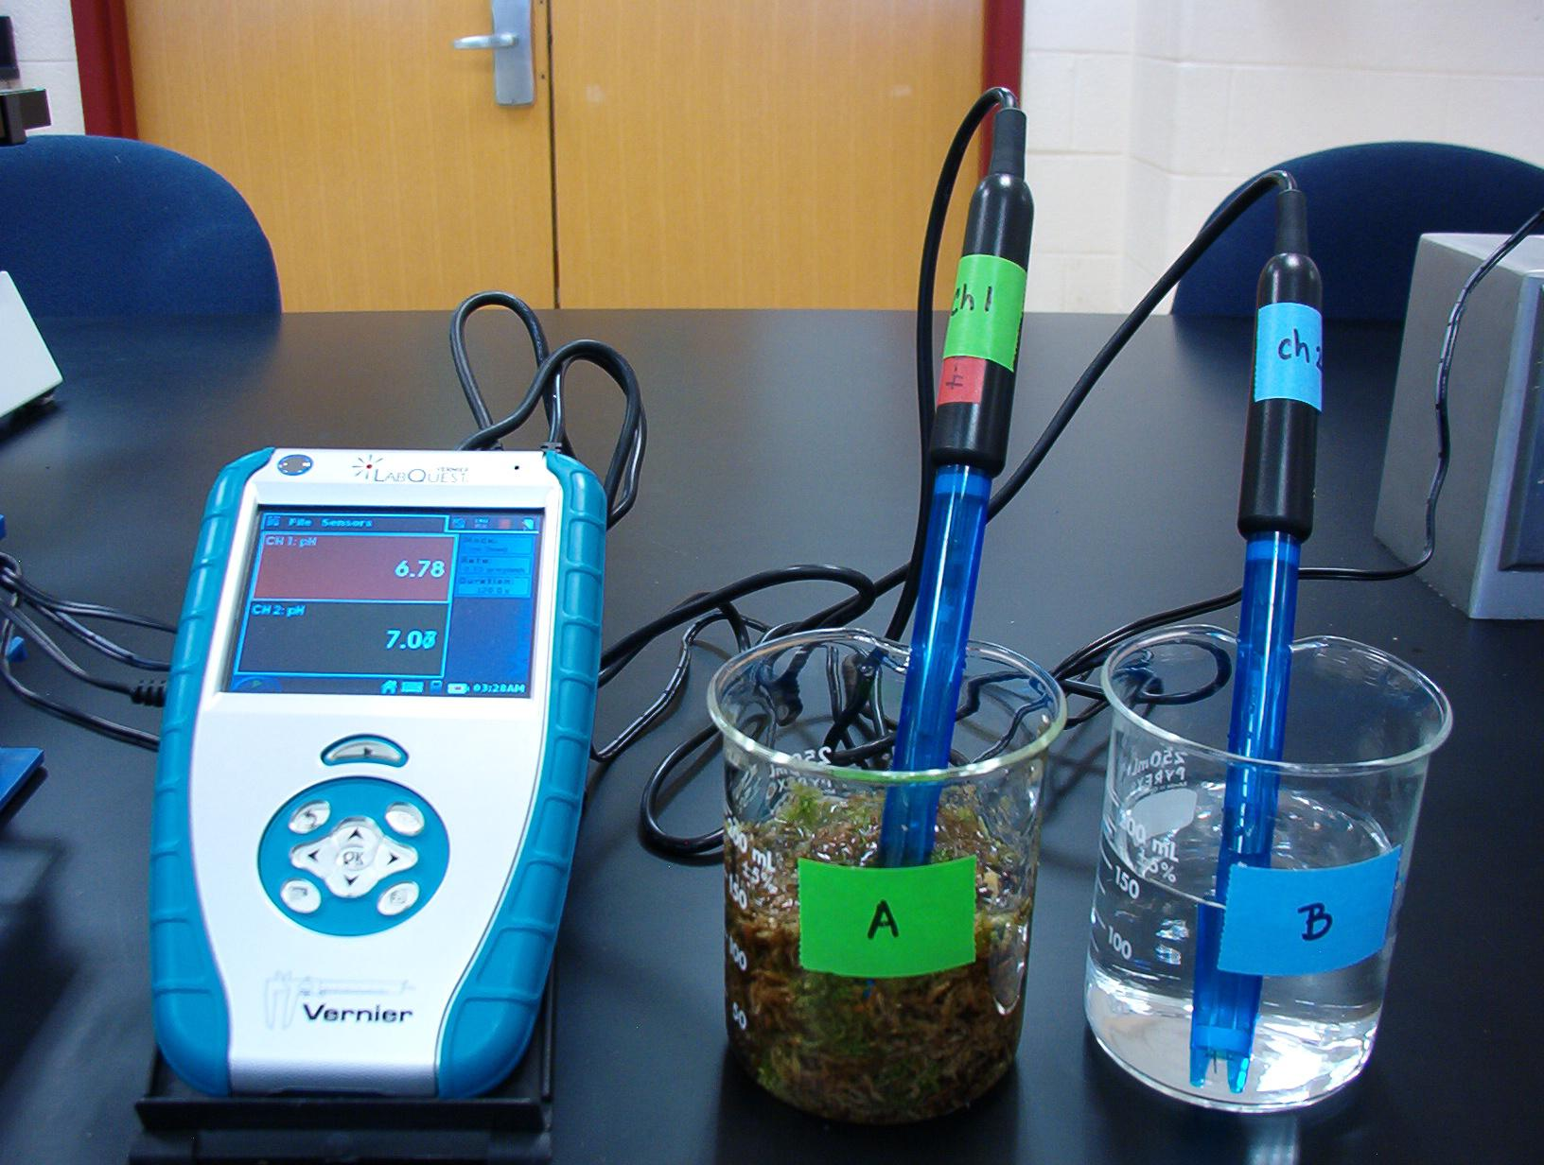
- To beaker A, add 10 grams of rinsed Sphagnum to beaker B add 10 grams of Elodea, Egeria or Duckweed. Start the timer. Record A and B for Sphagnum and Elodea.

- Every minute, record the pH of the water in each beaker for a total of 15 minutes (Table 1).

- Your instructor will set up beaker “C” and provide this data to you. Enter this information in Table 1.

- Remove the pH electrodes, rinse them, and return them to the “holding fluid”.

- Remove the plant materials from the beakers and place them in the “Used Plants” trays.

- Rinse out the beakers and return these to your lab bench.
- Plot the data in Table 1. What is your dependent variable? ________________ What is your independent variable? ____________________

Table 1. pH Measurements of Sphagnum and Elodea in Conditioned Tap Water

Time, minutes | Beaker A  (Sphagnum) | Beaker B  (Elodea) | Beaker C  (Water only)
0
1
2
3
4
5
6
7
8
9
10
11
12
13
14
15

Part A. Questions for Discussion (Instructor-Centered):

- What was the purpose of beaker “C”?

- What happened to the pH of the water in beaker “A”?

- Based on what you know about pH and cells, how is Sphagnum chemically affecting the water pH?

- What advantage does this provide Sphagnum in its environment?

- What is the purpose of beaker “B” which contained the aquatic plant? What happened to the pH of the water in this beaker?

Part B. Experimental Question:

What role do ions (specifically sodium ions) play in Sphagnum’s ability to alter the pH of its environment?

Compose a hypothesis:

Materials:
- 2 x 250 mL beakers (or similar sized containers)
- Conditioned tap water (or Pond or Spring water)
- 300 mL of 0.5% NaCl (in conditioned tap water)
- graduated cylinder
- Sphagnum moss, rinsed (Carolina Biological Supply Co. #156740)
- Digital balance
- Vernier LabQuest unit with two pH electrodes
- Timer
- Squirt bottle of distilled water to rinse electrode
- Waste beaker for catching rinse water

Procedure:
- Obtain two clean beakers, labeled “D” and “E”.
- Measure and add 150 mL of 0.5% NaCl to each beaker.
- The pH electrodes should be in a “holding solution”. Rinse one pH electrode and place in Beaker D, rinse the other electrode and place in Beaker E. Note which channel (1 or 2) each electrode is connected to.

- When the pH stabilizes, record the initial values (Time 0) for each beaker in Table 2.
- To beaker E, add 10 grams of rinsed Sphagnum. Start the timer.
- Every minute, record the pH of the water in each beaker for a total of 15 minutes (Table 2).

- Remove the pH electrodes, rinse them and return them to the “holding fluid”.
- Remove the plant materials from the beakers and place them in the “used plants” trays.

- Rinse out the beakers and return these to your lab bench.
- Plot the data in Table 2. What is your dependent variable? ________________ What is your independent variable? ____________________

Table 2. pH Measurements of Sphagnum exposed to Salt Water

Time, minutes | Beaker D  (0.5% NaCl) | Beaker E  (Sphagnum in 0.5% NaCl)
0
1
2
3
4
5
6
7
8
9
10
11
12
13
14
15
Part B. Questions for Discussion (Instructor-Centered):

- What was the role of beaker D?

- What happened to the pH of the water in beaker E?

- What role do sodium ions (Na⁺) play in this experiment?

- Was there a difference between the results you saw for beakers A and E? If so, what may account for this?

- What conclusions can you draw from this experiment?

Student-Centered Questions:
- Based on your findings, identify a question that you would like to investigate to better understand how the moss is affecting its environment.

- Generate a hypothesis from this question.

- Design and describe an experiment to test your question

Dry sphagnum, such as is used by greenhouses for potting material, can also be used. Substitute approximately 3 grams of dry Sphagnum, add it directly to the beaker of water or solution and begin taking measurements.

